## Document for configuring Scheduled [Auto Start and Stop Your EC2 Instances](https://schen1628.wordpress.com/2014/02/04/auto-start-and-stop-your-ec2-instances/) of AWS instances

## This document highlight steps to create a Instance in AWS using a CloudFormation. The instance runs as python script using cron job every five minutes and monitor instances within the AWS environment for scheduled START/STOP based on tags created.

## The cron can be adjusted based on requirement. Below attached the cloud formation script used for creating the EC2-Scheduler instance.

## 

## **note: change/add the latest ami for the instance within the json file. Also add the job scheduler instance keypair details in the json file.

## Steps for creating the Cloudformation Stack.

## Login into the AWS Management console

## Create a Key Pair (Ec2-Scheduler) to be used for the Job Scheduler Instance

## Browse to Services>Management Tools>CloudFormation

## Click the appropriate region to launch the CloudFormation Stack

## Follow below step to create Stack

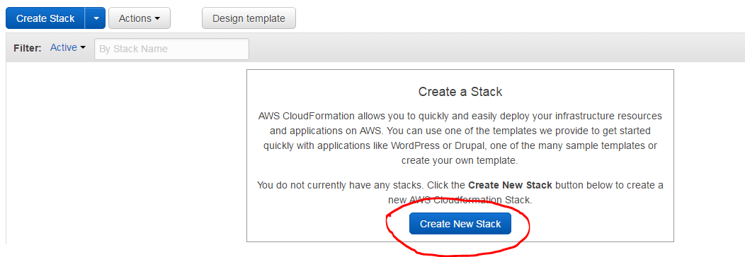

## Click Choose File option and select the file ec2_operator.json

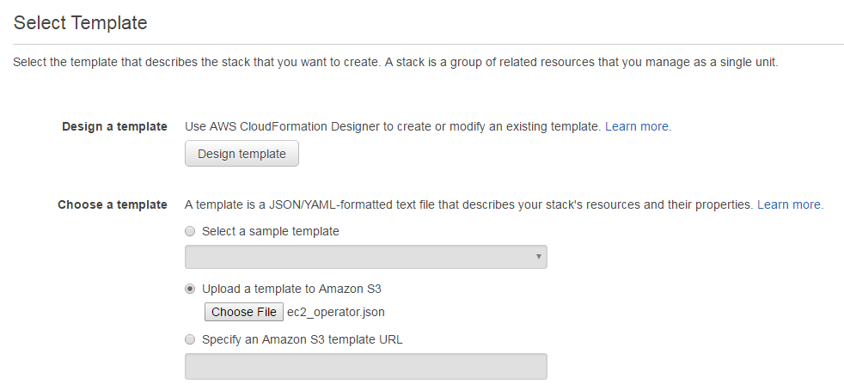

## Click Next

## Add the CloudFormation Stack name and check for the keypair generated within step B above

## Note: t2.micro: The interface defaults to t2.micro which according to this requires a VPC

## *Error: The specified instance type can only be used in a VPC. A subnet ID or network interface ID is required to carry out the request. (VPCResourceNotSpecified)*

## Hence select *c3.large instance Type* Refer [VPC](http://docs.aws.amazon.com/AWSEC2/latest/UserGuide/instance-types.html)

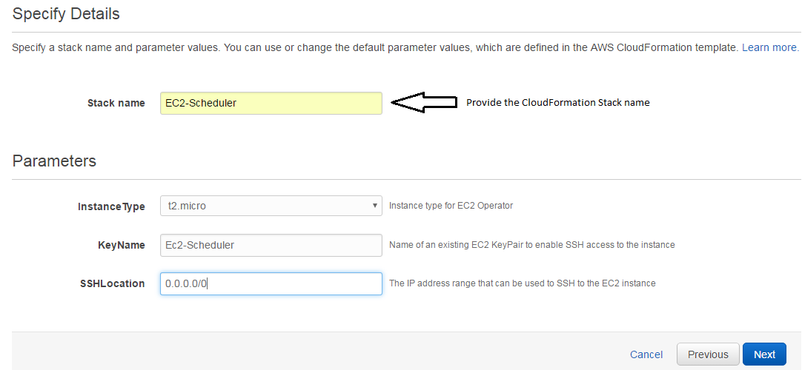

1. Add tags as required and click next

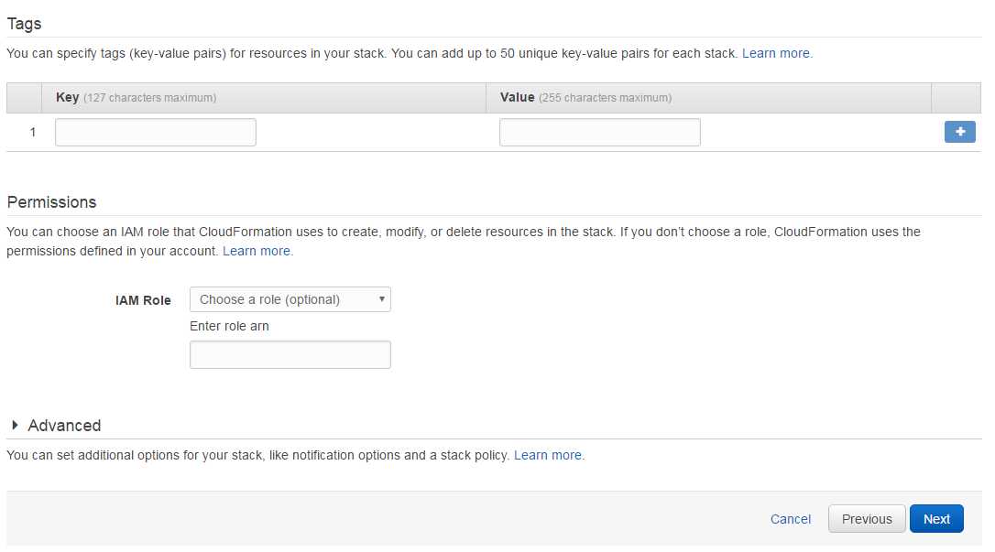

1. Review and click next, the stack creation process will start

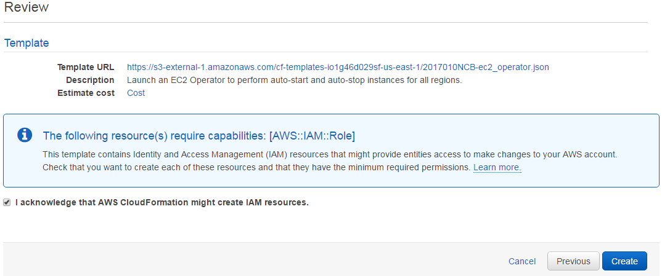

1. Check for stack creation process and other details

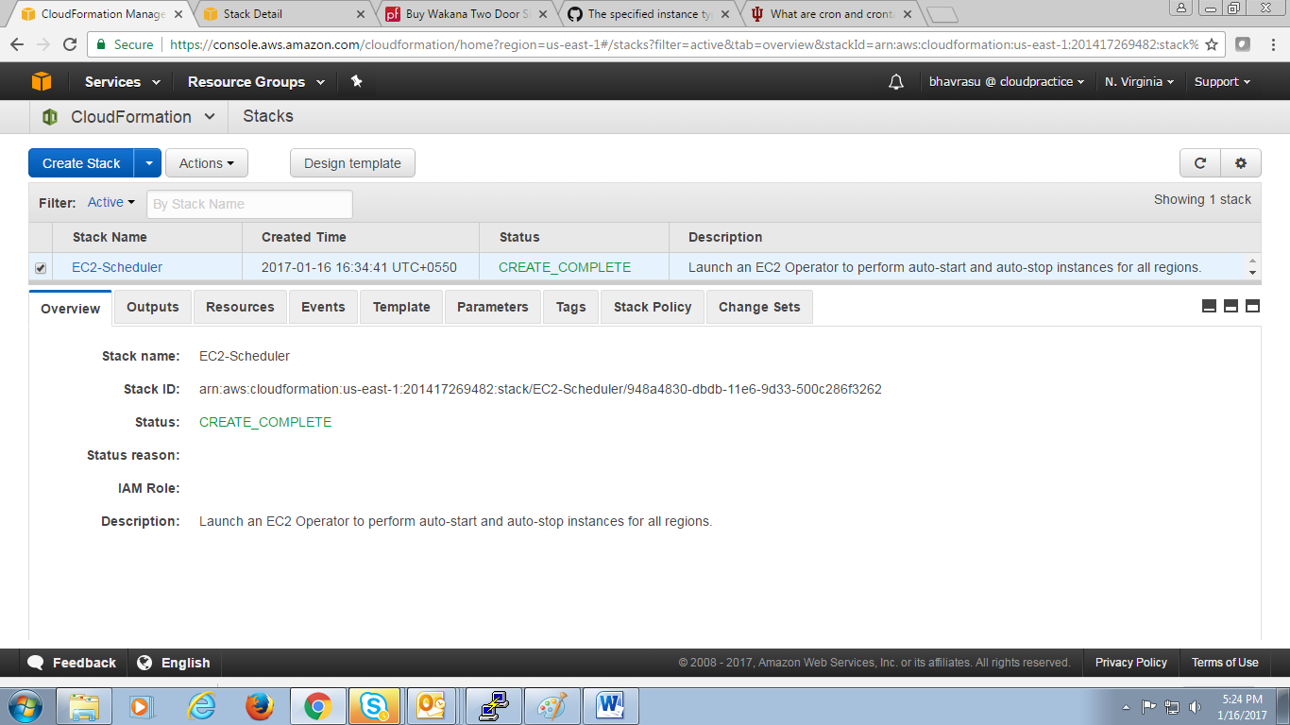

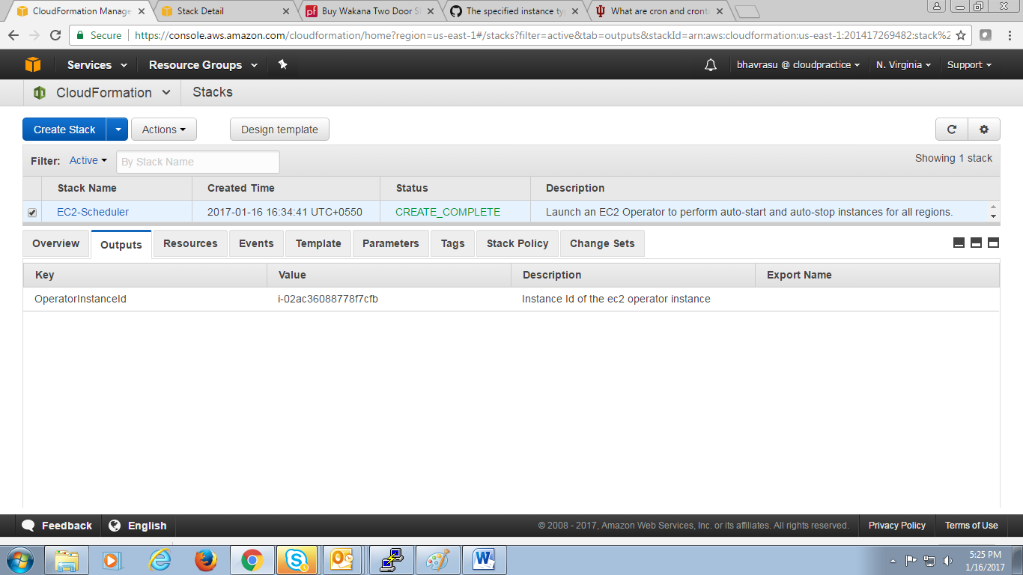

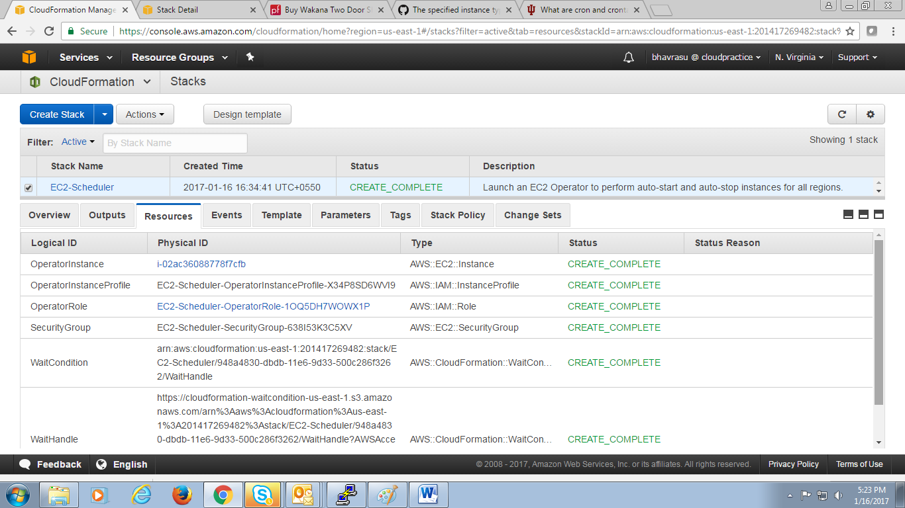

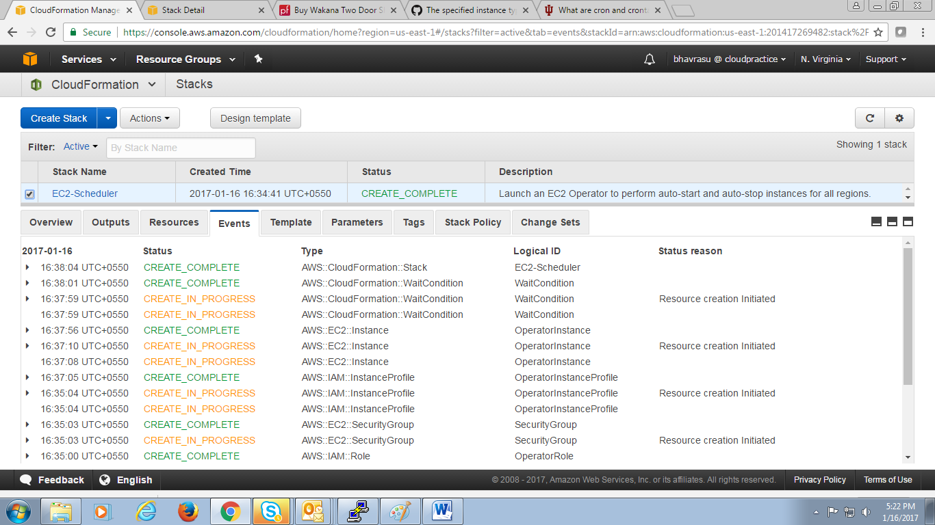

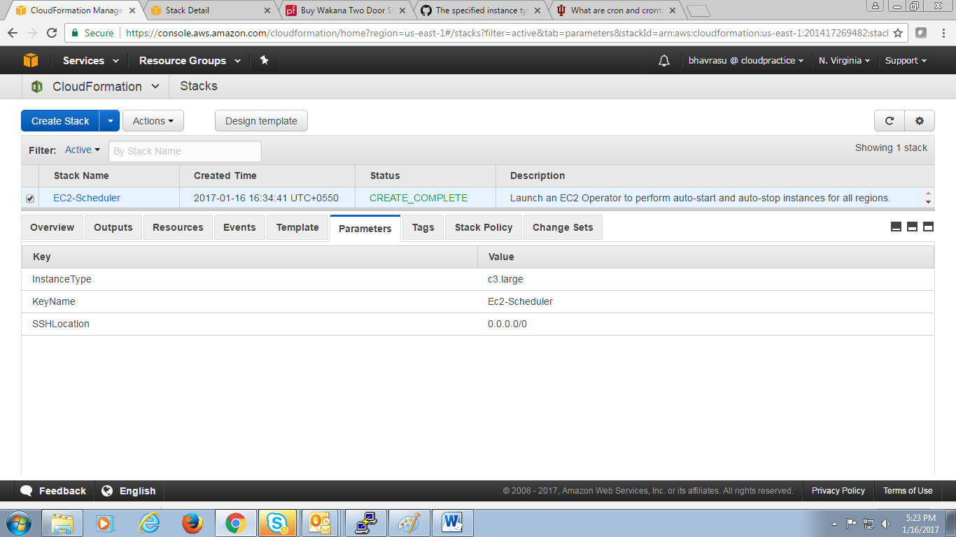

Template Design view

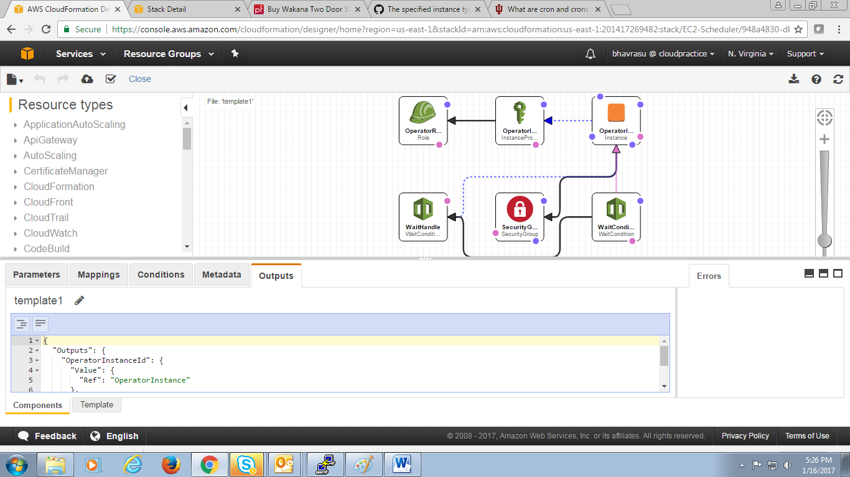

## Tagging the instance in the AWS Environment

## Within this step, need to provide tags to each instance in AWS Environment.

## Each instance will have Two tags, with values defined in form of cronjob syntax

## auto:start

## auto:stop

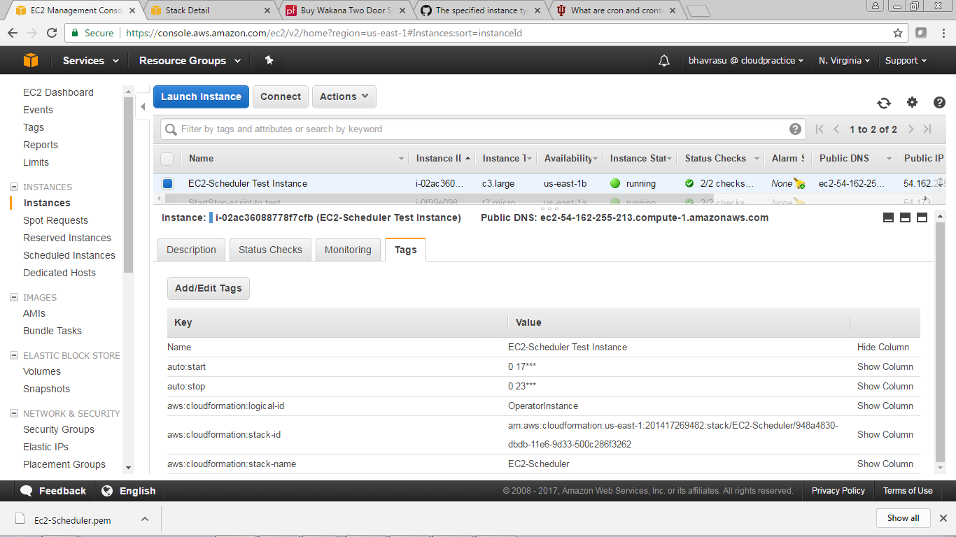

The instance tag with the tags defined at instance level will start and stop as per the values defined.

## Using Putty,Login to the above created instance using login as ec2-user. Locate the python script on AWS Scheduler instance in the following directory

/home/ec2-user/ec2_operator.py

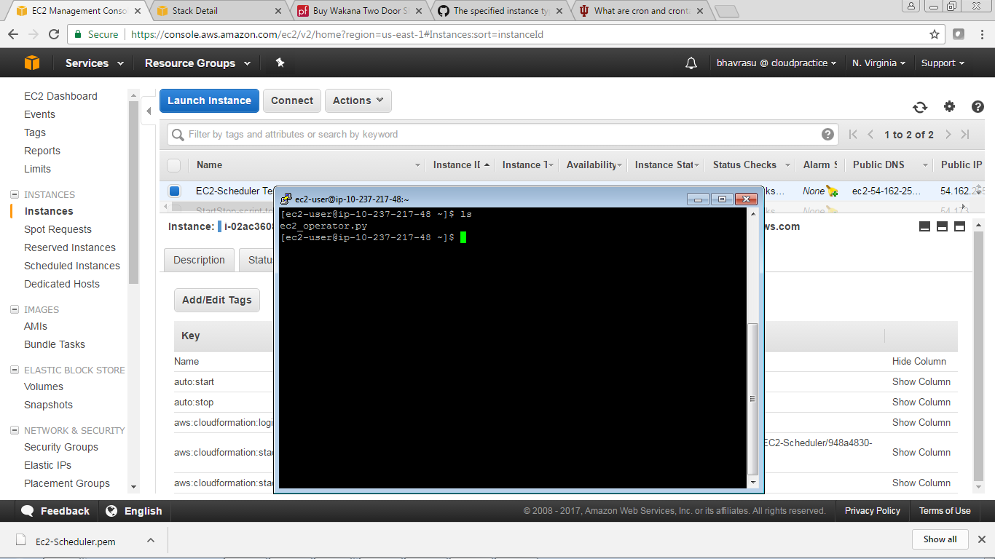

* 1. list the cron jobs using following command: crontab -l



## To view the Scheduled Cron job use command : vi /etc/crontab

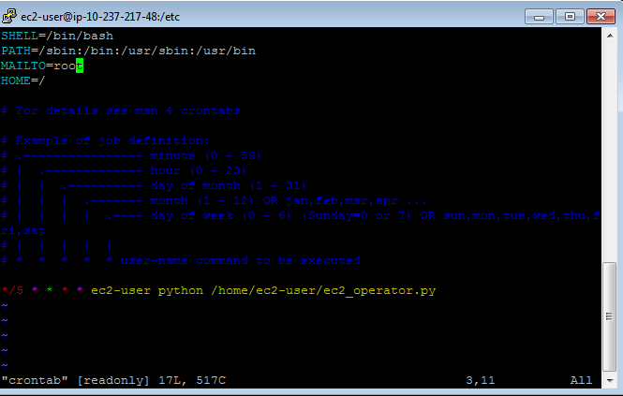

## 1.6 Logging feature

## The Python script does not write any logs. You can edit /etc/crontab on the server to redirect outputs and errors to a log file. You should see something like this in your /etc/crontab file:

*/5 * * * * ec2-user python /home/ec2-user/ec2_operator.py

Change it to something like it to redirect outputs and errors to /home/ec2_operator.log:

*/5 * * * * ec2-user python /home/ec2-user/ec2_operator.py > /home/ec2-user/ec2_operator.log 2>&1